QUESTION:

Given 2 sorted arrays A and B of size n each. Write an algorithm to find the median of the array obtained after merging the above 2 arrays(i.e. array of length 2n). The complexity should be O(log(n))

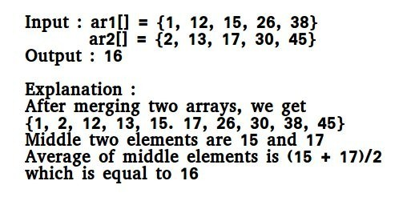

|  |  |
| --- | --- |
| EXP NO: | **MEDIAN FINDING** |
| DATE : |

**AIM:**

To find the median of two arrays after merging it.

**PSEUDOCODE:**

m1=median(arr1,n);

m2=median(arr2,n);

if(m1<m2)

{

if(n%2==0)

return getmedian(arr1+(n/2-1),arr2,n-n/2+1);

return getmedian(arr1+(n/2),arr2,n-n/2);

}

else

{ if(n%2==0)

return getmedian(arr1,arr2+(n/2-1),n-n/2+1);

return getmedian(arr1,arr2+(n/2),n-n/2);

}

**SOURCE CODE:**

#include<stdio.h>

int median(int arr[],int n)

{

int middle=n/2;

if(n%2==0)

return (arr[middle]+arr[middle+1])/2 ;

else

return arr[middle];

}

int max(int val1,int val2)

{

if(val1>val2)

return val1;

else

return val2;

}

int min(int val1,int val2)

{

if(val1>val2)

return val2;

else

return val1;

}

int getmedian(int arr1[],int arr2[],int n)

{

int m1,m2;

if(n==1)

return (arr1[0]+arr2[0])/2;

if(n==2)

return (max(arr1[0],arr2[0])+min(arr1[1],arr2[1]))/2;

m1=median(arr1,n);

m2=median(arr2,n);

if(m1<m2)

{

if(n%2==0)

return getmedian(arr1+(n/2-1),arr2,n-n/2+1);

return getmedian(arr1+(n/2),arr2,n-n/2);

}

else

{ if(n%2==0)

return getmedian(arr1,arr2+(n/2-1),n-n/2+1);

return getmedian(arr1,arr2+(n/2),n-n/2);

}

}

void main()

{

printf("Enter the number of values :");

int n,i;

scanf("%d",&n);

int arr1[n],arr2[n];

printf("Enter the elements for array1\n");

for(i=0;i<n;i++)

{

scanf("%d",&arr1[i]);

}

printf("Enter the elements for array2\n");

for(i=0;i<n;i++)

{

scanf("%d",&arr2[i]);

}

printf("The median is :%d\n",getmedian(arr1,arr2,n));

}

**\**

**OUTPUT:**

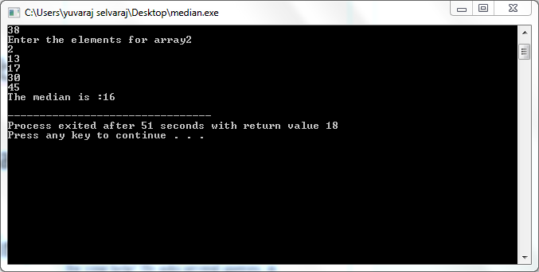

**RESULT:**

Thus the program was compiled and executed successfully.

**QUESTION:**

To perform heap sort for the given array using heapify function

**Input:**

5

5

4

3

2

1

**Output:**

1

2

3

4

5

|  |  |
| --- | --- |
| EXP NO: | **HEAP SORT** |
| DATE : |

**AIM:**

To Find the sorted array using heap sort

**PSEUDOCODE:**

void heapify(int a[],int n) {

for (k=1;k<n;k++) {

item = a[k];

i = k;

j = (i-1)/2;

while((i>0)&&(item>a[j])) {

a[i] = a[j];

i = j;

j = (i-1)/2;

}

a[i] = item;

}}

**SOURCE CODE:**

#include<stdio.h>

void heapsort(int[],int);

void heapify(int[],int);

void adjust(int[],int);

main() {

int n,i,a[50];

printf("\nEnter the limit:");

scanf("%d",&n);

printf("\nEnter the elements:");

for (i=0;i<n;i++)

scanf("%d",&a[i]);

heapsort(a,n);

printf("\nThe Sorted Elements Are:\n");

for (i=0;i<n;i++)

printf("\t%d",a[i]);

printf("\n");

}

void heapsort(int a[],int n)

{

int i,t;

heapify(a,n);

for (i=n-1;i>0;i--) {

t = a[0];

a[0] = a[i];

a[i] = t;

adjust(a,i);

}}

void heapify(int a[],int n) {

int k,i,j,item;

for (k=1;k<n;k++) {

item = a[k];

i = k;

j = (i-1)/2;

while((i>0)&&(item>a[j])) {

a[i] = a[j];

i = j;

j = (i-1)/2;

}

a[i] = item;

}}

void adjust(int a[],int n) {

int i,j,item;

j = 0;

item = a[j];

i = 2*j+1;

while(i<=n-1) {

if(i+1 <= n-1)

if(a[i] <a[i+1])

i++;

if(item<a[i]) {

a[j] = a[i];

j = i;

i = 2*j+1;

}

else

break;

}

a[j] = item;

}

**OUTPUT:**

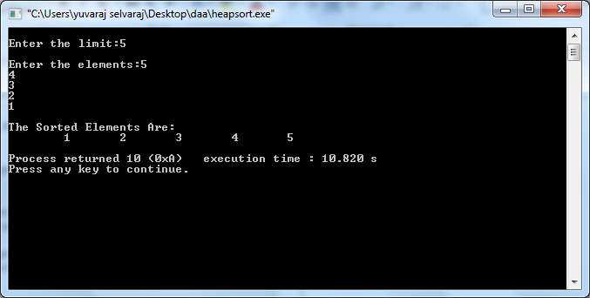

**RESULT:**

Thus the program was compiled and executed successfully.

**QUESTION:**

To multiply two large numbers using dvide and conquer strategy

**Input:**

100

100

**Output:**

10000

|  |  |
| --- | --- |
| EXP NO: | **MULTIPLICATION OF TWO LARGE INTEGERS** |
| DATE : |

**AIM:**

To implement the program to find the product of two large integers.

**PSEUDOCODE:**

for (int i=n1-1; i>=0; i--)

{

int carry = 0;

int n1 = num1[i] - '0';

i_n2 = 0;

for (int j=n2-1; j>=0; j--)

{

int n2 = num2[j] - '0';

int sum = n1*n2 + result[i_n1 + i_n2] + carry;

carry = sum/10;

result[i_n1 + i_n2] = sum % 10;

i_n2++;

}

if (carry > 0)

result[i_n1 + i_n2] += carry;

i_n1++;

}

int i = result.size() - 1;

while (i>=0 && result[i] == 0)

i--;

if (i == -1)

return "0";

string s = "";

while (i >= 0)

s += std::to_string(result[i--]);

return s;

**SOURCE CODE:**

#include<bits/stdc++.h>

using namespace std;

string multiply(string num1, string num2)

{

int n1 = num1.size();

int n2 = num2.size();

if (n1 == 0 || n2 == 0)

return "0";

vector<int> result(n1 + n2, 0);

int i_n1 = 0;

int i_n2 = 0;

for (int i=n1-1; i>=0; i--)

{

int carry = 0;

int n1 = num1[i] - '0';

i_n2 = 0;

for (int j=n2-1; j>=0; j--)

{

int n2 = num2[j] - '0';

int sum = n1*n2 + result[i_n1 + i_n2] + carry;

carry = sum/10;

result[i_n1 + i_n2] = sum % 10;

i_n2++;

}

if (carry > 0)

result[i_n1 + i_n2] += carry;

i_n1++;

}

int i = result.size() - 1;

while (i>=0 && result[i] == 0)

i--;

if (i == -1)

return "0";

string s = "";

while (i >= 0)

s += std::to_string(result[i--]);

return s;

}

int main()

{

string str1 ;

string str2 ;

cin>>str1;

cin>>str2;

cout << multiply(str1, str2);

return 0;

}

**OUTPUT:**

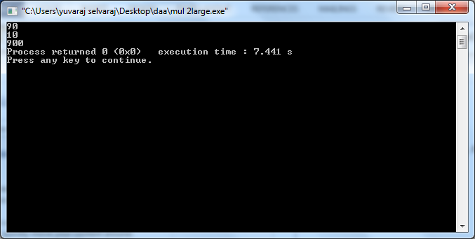

**RESULT:**

Thus the program was compiled and executed successfully.

**QUESTION:**

Given a cost matrix cost[][] and a position (m, n) in cost[][], write a function that returns cost of minimum cost path to reach (m, n) from (0, 0). Each cell of the matrix represents a cost to traverse through that cell.

Total cost of a path to reach (m, n) is sum of all the costs on that path (including both source and destination).

You can only traverse down, right and diagonally lower cells from a given cell, i.e., from a given cell (i, j), cells (i+1, j), (i, j+1) and (i+1, j+1) can be traversed.

You may assume that all costs are positive integers.

**Input:**

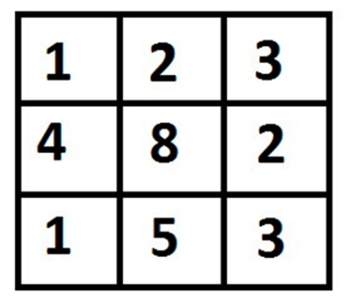

**(2,2)**

**Output:**

The output is an integer indicating the sum of the shortest path.

Ans:8

|  |  |
| --- | --- |
| EXP NO: | MATRIX MIN COST |
| DATE : |

**AIM:**

To find the shortest path to go to a position in a given matrix

**PSEUDOCODE:**

for (i = 1; i <= m; i++)

tc[i][0] = tc[i-1][0] + cost[i][0];

for (j = 1; j <= n; j++)

tc[0][j] = tc[0][j-1] + cost[0][j];

for (i = 1; i <= m; i++)

for (j = 1; j <= n; j++)

tc[i][j] = min(tc[i-1][j-1],

tc[i-1][j],

tc[i][j-1]) + cost[i][j];

return tc[m][n];

**SOURCE CODE:**

#include<stdio.h>

#include<limits.h>

#define R 3

#define C 3

int min(int x, int y, int z);

int minCost(int cost[R][C], int m, int n)

{

int i, j;

int tc[R][C];

tc[0][0] = cost[0][0];

for (i = 1; i <= m; i++)

tc[i][0] = tc[i-1][0] + cost[i][0];

for (j = 1; j <= n; j++)

tc[0][j] = tc[0][j-1] + cost[0][j];

for (i = 1; i <= m; i++)

for (j = 1; j <= n; j++)

tc[i][j] = min(tc[i-1][j-1],

tc[i-1][j],

tc[i][j-1]) + cost[i][j];

return tc[m][n];

}

int min(int x, int y, int z)

{

if (x < y)

return (x < z)? x : z;

else

return (y < z)? y : z;

}

int main()

{

int cost[R][C] = { {1, 2, 3},

{4, 8, 2},

{1, 5, 3} };

printf(" %d ", minCost(cost, 2, 2));

return 0;

}

**OUTPUT:**

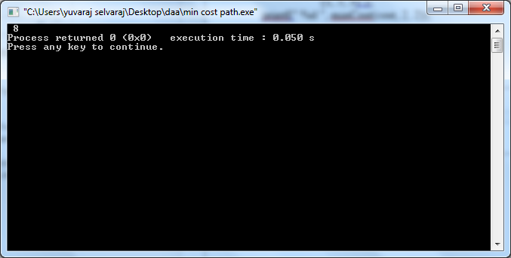

**RESULT:**

Thus the program was compiled and executed successfully

QUESTION:

given two integer arrays val[0..n-1] and wt[0..n-1] which represent values and weights associated with n items respectively. Also given an integer W which represents knapsack capacity, find out the maximum value subset of val[] such that sum of the weights of this subset is smaller than or equal to W. You cannot break an item, either pick the complete item, or don’t pick it

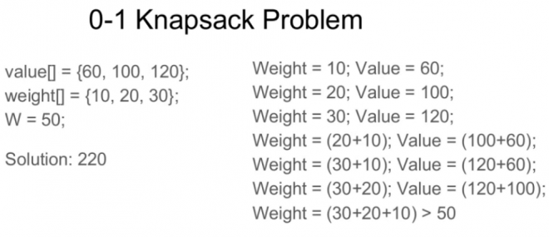

|  |  |
| --- | --- |
| EXP NO: | 0-1 KNAPSACK PROBLEM |
| DATE : |

**AIM:**

To find the max profit either by taking the cost or dropping

**PSEUDOCODE:**

for(i = 1; i <= n; i++)

{

for(j = 1; j <= Capacity; j++)

{

if((j - Weight[i]) < 0)

Knapsack01[i][j] = Knapsack01[i-1][j];

else

Knapsack01[i][j] = Max(Knapsack01[i-1][j], Profit[i] +

Knapsack01[i-1][j-Weight[i]]);

}

}for(i = 0; i <= n; i++)

{

for(j = 0; j <= Capacity; j++)

printf("%d ", Knapsack01[i][j]);

printf("\n");

}

return Knapsack01[n][Capacity];

**SOURCE CODE:**

#include<stdio.h>

int Knapsack_01(int Item[], int Profit[], int Weight[], int Capacity, int n);

void main()

{

int n, i;

printf("Enter the value of n : ");

scanf("%d", &n);

int Item[n], Profit[n], Weight[n], Capacity;

printf("Enter %d items Profit and Weight :\n", n);

for(i=1; i<=n; i++)

{

Item[i] = i;

printf("Enter item %d Profit and Weight : ", Item[i]);

scanf("%d %d", &Profit[i], &Weight[i]);

}

printf("Enter the Knapsack Capacity : ");

scanf("%d", &Capacity);

printf("Maximum Profit attained with Knapsack of capacity %d with %d Items is %d\n",

Capacity, n, Knapsack_01(Item, Profit, Weight, Capacity, n));

}

int Knapsack_01(int Item[], int Profit[], int Weight[], int Capacity, int n)

{

int Knapsack01[n + 1][Capacity + 1], i, j;

for(i = 0; i <= n; i++)

Knapsack01[i][0] = 0;

for(j = 0; j <= Capacity; j++)

Knapsack01[0][j] = 0;

for(i = 1; i <= n; i++)

{

for(j = 1; j <= Capacity; j++)

{

if((j - Weight[i]) < 0)

Knapsack01[i][j] = Knapsack01[i-1][j];

else

Knapsack01[i][j] = Max(Knapsack01[i-1][j], Profit[i] +

Knapsack01[i-1][j-Weight[i]]);

}

}for(i = 0; i <= n; i++)

{

for(j = 0; j <= Capacity; j++)

printf("%d ", Knapsack01[i][j]);

printf("\n");

}

return Knapsack01[n][Capacity];

}

int Max(int a, int b)

{

return (a>b) ? a : b;

}

**OUTPUT:**

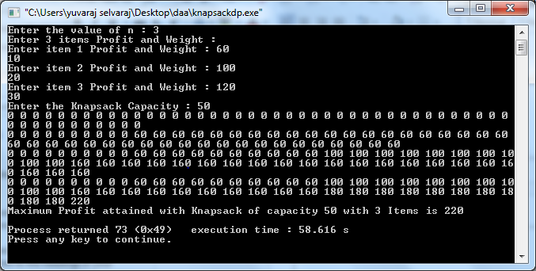

**RESULT:**

Thus the program was compiled and executed successfully.

**QUESTION**:

Given weights and values of n items, we need put these items in a knapsack of capacity W to get the maximum total value in the knapsack.

In the 0-1 Knapsack problem, we are not allowed to break items. We either take the whole item or don’t take it.

**Input**:

Items as (value, weight) pairs

arr[] = {{60, 10}, {100, 20}, {120, 30}}

Knapsack Capacity, W = 50;

**Output**:

Maximum possible value = 220

by taking items of weight 20 and 30

|  |  |
| --- | --- |
| EXP NO: | **FRACTIONAL KNAPSACK** |
| DATE : |

**AIM:**

To find the max profit using fractional knapsack

**PSEUDOCODE:**

while(rc){

if(w[i]<=rc){

x[i]=1;

profit+=p[i]*x[i];

rc-=w[i];

}

else{

x[i]=(float)rc/(float)w[i];

profit+=p[i]*x[i];

rc=0;

}

i++;

}

**SOURCE CODE:**

#include<stdio.h>

void main(){

int i,j,n;

int max;

int rc;

printf("Enter the maximun capacity : ");

scanf("%d",&max);

printf("Enter number of Items : ");

scanf("%d",&n);

float x[n];

int w[n];

int p[n];

float ratio[n];

float profit=0;

printf("*** Enter profit and weight ***\n");

for(i=0;i<n;i++){

x[i]=0;

printf("Item : %d\n",i+1);

scanf("%d %d",&p[i],&w[i]);

ratio[i]=(float)p[i]/(float)w[i];

}

for(i=0;i<n;i++){

for(j=0;j<n;j++){

if(ratio[i]>ratio[j]){

int temp1=w[i];

w[i]=w[j];

w[j]=temp1;

int temp2=p[i];

p[i]=p[j];

p[j]=temp2;

float temp3=ratio[i];

ratio[i]=ratio[j];

ratio[j]=temp3;

}

}

}

rc=max;

i=0;

while(rc){

if(w[i]<=rc){

x[i]=1;

profit+=p[i]*x[i];

rc-=w[i];

}

else{

x[i]=(float)rc/(float)w[i];

profit+=p[i]*x[i];

rc=0;

}

i++;

}

printf("Profit : %.2f\n",profit);

}

**OUTPUT:**

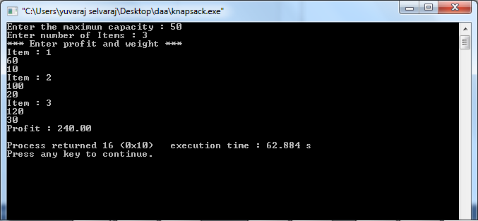

**RESULT:**

Thus the program was compiled and executed successfully.